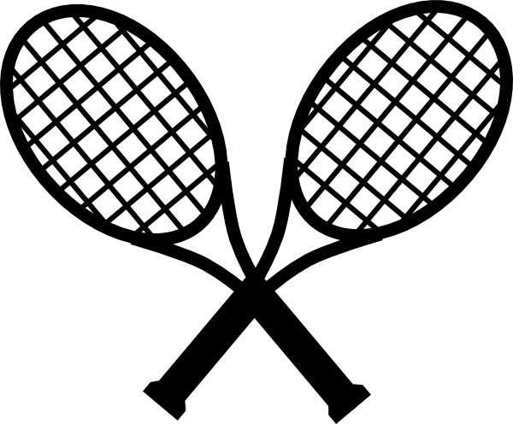 Bemidji Summer Tennis 2018

Elementary Program: Players will get a GREAT introduction to Bemidji Tennis! Our goal is to make this summer program a positive experience for every young athlete involved. We focus on every skill and experience level, which means players get a mixture of individual instruction, large group games, small group activities, and frequent competitions with and against their coaches!

Middle Level Program: The Middle School program maintains the same principle of providing a positive experience for every athlete, while adding an emphasis on further player development and competitive play. We will also be adding weekly tournament play.

Middle School “Aces”: Following player evaluations during the first week of tennis, middle school players will have the option of participating in an additional competitive program in the evenings at Bemidji High School. This program will focus on preparing for tournament and competitive match play at the high school level. Multiple coaches will participate in the evaluations.

Director: Mark Fodness (Head Coach at BHS and BSU) Youth Director: Kyle Fodness (BMS Head Coach)
Assistant Coaches: Coaches at every level have considerable high school and collegiate playing experience, and their tremendous work allows us to keep a low player/coach ratio for drills, activities, and small group work in all of our sessions.

To Register
Via Mail: Kyle Fodness, 3506 Cedar Ln NW, Bemidji, MN 56601 Via Website: www.bemidjitennis.com
Fee: Cash or check to Bemidji Tennis (any online registrations will have to pay in person on the first day, or by mail)

* You can bring your registration and fee to the first day, but please email bemidjitennis@gmail.com or register online so we know who will be attending. Register or notify us by May 25th to guarantee a shirt. We will still accept registrations after May 25th.
Contact: (Kyle Fodness) Cell: 218-407-7898 Email: bemidjitennis@gmail.com Online: www.bemidjitennis.com

Location: Bemidji Middle School Tennis Complex
Dates: Monday - Thursdays, June 6th – July 12. NO TENNIS JULY 4th & JULY 5th

Free breakfast and lunch are available through the ISD #31 summer lunch program before and after these sessions at BMS!

------------------------------------------------------------------------------------------------------------------------------------------------------------------

Player Name: _______________________________________________________________________ (Circle one) Boy’s Group or Girl’s Group

Circle Grade (2nd Graders and 5th Graders can choose either available session option based on experience and preference)

8:15 - 9:15 M W Grade 1 2 (grade going into next fall) $80.00 (includes free shirt)

9:00 - 10:15 M T W Th Grade 2 3 4 5 (grade going into next fall) $125.00 (includes free shirt)
10:15 - 11:30 M T W Th Grade 5 6 7 8 (grade going into next fall) $125.00 (includes free shirt)

Each player pays one price and is eligible to attend any sessions they would like during the week. You just pick the days that fit your schedule each week! This lets parents and players be flexible with other sports, family trips, and other activities in the summer.
* The second player per family registers for $60. Any additional players beyond 2 per family, the cost is $30 per additional player. BHS players count as the first player per family.

T-Shirt:
Youth: Small______ Medium______ Large______ Adult: Small______ Medium ______ Large______ Extra Large______

Parent/Guardian(s):___________________________________________________________________________________________________________________

(Circle Emergency Contact) Phone: __________________________ Parent Cell(s): ____________________________ ______________________________

Email (print very clearly please):________________________________________________________________________________________________________

* Extended payment schedule options and/or limited assistance available upon request.
* Proceeds after expenses will go to the Bemidji Tennis non-profit organization and its support of Lumberjacks Tennis programs.

